Representation for turning right into Turnham Green Terrace from Chiswick High Road

PCN number:
I make representations against the above numbered PCN on the ground that the contravention did not occur as the signage is unclear and inadequate to convey the restriction. As such “there was no failure to comply with an indication” under 1(4)(b)(ii) of Schedule 1 of London Local Authorities and Transport for London Act 2003.
I saw no signs that inform of this restriction. Upon receipt of the PCN I made some investigations including viewing photographs and watching CCTV footage provided by the Council. I make the following observations in support of my contention.
- The sign 619 “Motor vehicles prohibited” on Turnham Green Terrace through which you are enforcing the contravention is not visible and provides no warning of the restriction.

On approaching Turnham Green Terrace from the Chiswick High Road the sign is not visible to the driver at all. For example, at the traffic lights, it is obscured by the actual lights and prior to reaching the lights it is too distant and oblique to observe and at most times it is obscured by oncoming traffic. On turning into Turnham Green Terrace it is only visible once oncoming traffic has cleared and the driver is committed to making the turn into Turnham Green Terrace. At this point the driver would rightly be looking into the road to ensure the safety of the turn, in particular as this is a busy pedestrian crossing. To look left for the sign could in fact be dangerous, but if at this point they did notice it, it would require the driver to stop, and reverse back onto Chiswick High Road (and a box junction) to avoid the contravention. This would be dangerous, and would be a contravention of the Highway Code Rule 201 “Do not reverse from a side road into a main road.”

- There is a sign 612 “No right turn for vehicular traffic” on the corner of Brackley Road and Chiswick High Road. This sign is also difficult to see, as it has bizarrely been angled away from oncoming traffic, such that it is more easily seen from the pavement across the road than it might by the motorist. This is in contrast to the very clear “No left turn” signs (into Annandale Road) located at the traffic lights at the Junction of Chiswick High Road, Turnham Green Terrace and Annandale Road. To this end, I observe that since 9 August, when enforcement of the restriction in Turnham Green Terrace began, there have been zero Moving Traffic Offences of vehicles turning left from Chiswick High Road into Annandale Road, but many hundreds or thousands (?) turning right into Turnham Green Terrace. This comparison in itself points to inadequate signage around the Turnham Green Terrace restriction.

I also understand that the sign 612 “No right turn for vehicular traffic” on the corner of Brackley Road and Chiswick High Road is in contravention of The Traffic Signs Regulations and General Directions 2016 (“TSRGD”), and therefore illegal. I also understand that Hounslow Borough Council have been aware of this and admitted this fact as long ago as 20 August, and those aware of the fact include its Leader Steve Curran, member of Cabinet for traffic Hanif Khan, and Assistant Director for Transport, Parking & Environmental Strategy Mark Frost (who signed the Order enforcing the restriction in Turnham Green Terrace). This places the officers and councillors in contravention of Traffic Signs Manual 2018, Last updated 2 March 2020, Chapter 3, LEGAL ASPECTS AND RESPONSIBILITIES [their emphasis, not mine], where 3.1 Responsibility, states: “3.4.1. Traffic signs in use on the highway must either be prescribed by TSRGD as amended, or be specially authorised by the national authority. Signs that are neither prescribed nor authorised are obstructions on the highway and must be removed.”

- There are clear road markings on Chiswick High Road, ahead of the traffic lights at the junction of Chiswick High Road and Turnham Green Terrace, indicating that a right turn is allowed. Unlike the sign 612 referenced above, the road markings are legal and in full compliance with TSRGD.
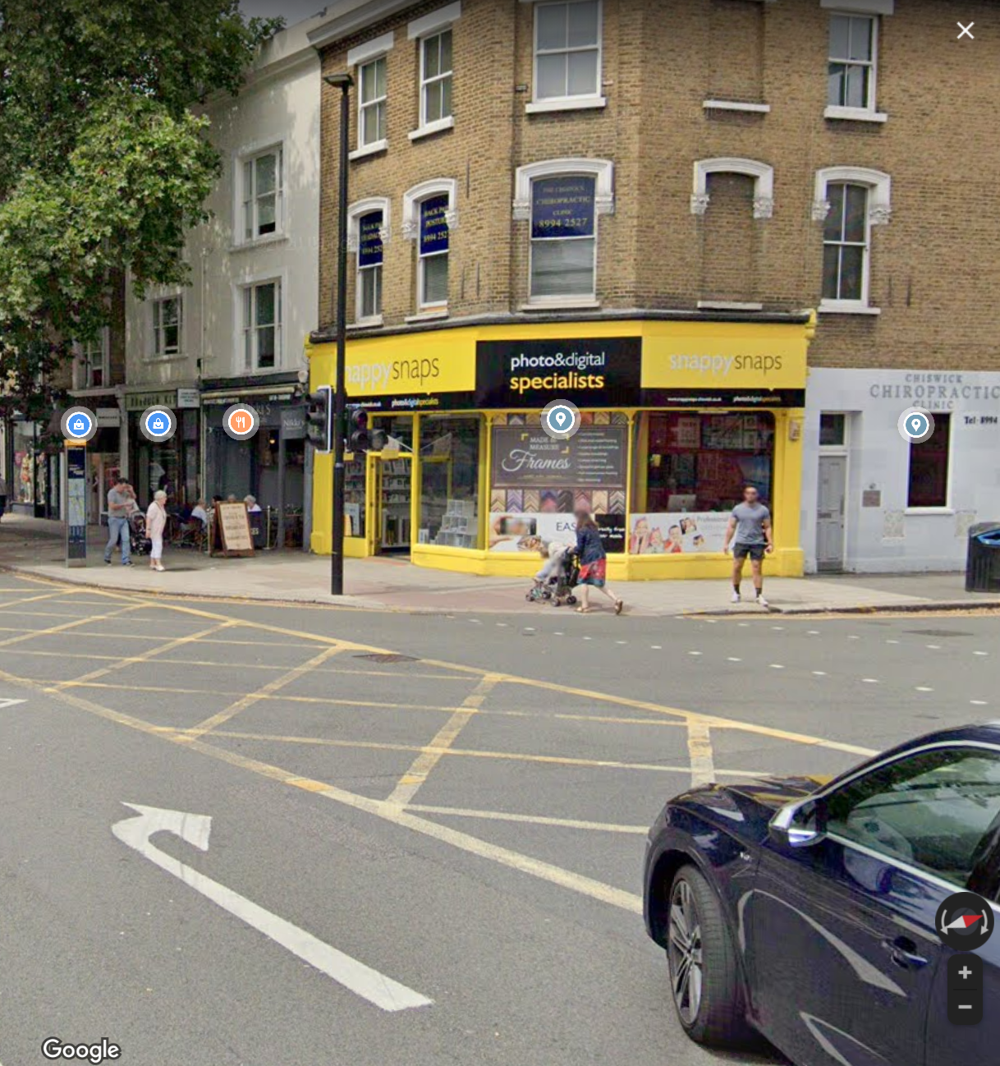

- Hounslow Council appears to have breached its commitments to best practice stated in their Parking and Traffic Enforcement Policy because the signage is unclear and inadequate.

“Adopting best practice guidance available, including enforcement operations that are … fair and are reasonable”

And

“Communicating clearly to motorists what regulations are in force”

I understand that in less than 2 months, over 7000 PCNs have been issued with regards to this single enforcement. (In comparison, in the 2018-19 year, ie 12 months, only 37,948 were issued in total in the entire Borough of Hounslow for Moving Traffic Contraventions.) This in itself provides strong evidence that it has not been clear to motorists what regulations are in force, because the signage is unclear and inadequate.

Conclusion
I have demonstrated above that:
- The sign through which the contravention is being enforced is not visible until the contravention has been made (and to undo the contravention would involve breaking traffic law and the Highway Code)
- There are no legal advance warnings signs of any restriction being enforced
- There are legal road markings indicating that a right turn can in fact be performed from Chiswick High Road into Turnham Green Terrace.
For these reasons I believe that the signage is evidently unclear and inadequate to convey the restriction. As such, there was no contravention of the Local Authorities and Transport for London Act 2003 and the PCN should be cancelled. I invite the Council to do so at the earliest opportunity.

