Representation for turning right into Fishers Lane from South Parade (night-time)
PCN number:
I make representations against the above numbered PCN on the ground that the contravention did not occur as the signage is illegal, unclear and inadequate to convey the restriction. As such “there was no failure to comply with an indication” under 1(4)(b)(ii) of Schedule 1 of London Local Authorities and Transport for London Act 2003.
I saw no signs at the time of the alleged contravention that inform of this moving traffic prohibition. Upon receipt of the PCN I made some investigations and I make the following observations in support of my contention. There are two specific grounds to my appeal:
- The signs enforcing the restriction are illegal
- The signs enforcing the restriction are invisible.

- The signs enforcing the restriction are illegal
The traffic order is enforced by two signs of type 619 “Motor vehicles prohibited”, as illustrated under item 12 of the sign table in Schedule 3, Part 2 of The Traffic Signs Regulations and General Directions 2016.
I made an inspection of the two signs and found the following:
- The sign situated in middle of the zebra crossing on Fishers Lane is illegal. It contravenes Regulation 8, Part 2 of the TSGDR 2016, Mounting of upright signs. It contravenes both paragraphs 1 and 2 of the regulation, complies with paragraph 5 and does not qualify for exceptions in paragraghs 3 and 4. The sign is, therefore, illegal.

- The second enforcement sign is also illegally sited. The “motor vehicles prohibited” sign is, according to the sign table in Schedule 3, Part 2 of The Traffic Signs Regulations and General Directions 2016, subject to Paragraph 1 of Part 5, The Schedule 3 General Directions, in which sub-paragraph 2 states “When the sign is placed to indicate the point at which a restriction, requirement or prohibition begins or ends, it must be placed as near as practicable to that point.”. The sign is clearly, in Ealing’s own pictures, not placed “as near as practicable to that point”, but in the middle of the pavement several metres away, whereas other signs are placed in what would be the correct location (where a post already exists). To that end, it is not surprising I did not see this sign as it was illegally positioned a long way from where it should be.
As the signage through which Ealing Council seeks to enforce the PCN has not been sited legally in accordance with The Traffic Signs Regulations and General Directions 2016, there was no contravention of the Local Authorities and Transport for London Act 2003 and the PCN should be cancelled. I invite the Council to do so at the earliest opportunity.

- The signs enforcing the restriction are invisible.

Since my alleged contravention occurred during hours of darkness, I also made a night-time visit to the site. This revealed that neither of the “prohibition of vehicles” signs is visible at night, at all!
As the photograph below shows, every sign at the junction except the two “prohibition of motor vehicles” signs is illuminated. This not only makes them easy to see, but their brighness masks the darkness of the two signs through which the contravention is enforced to such a point that they cannot be seen.
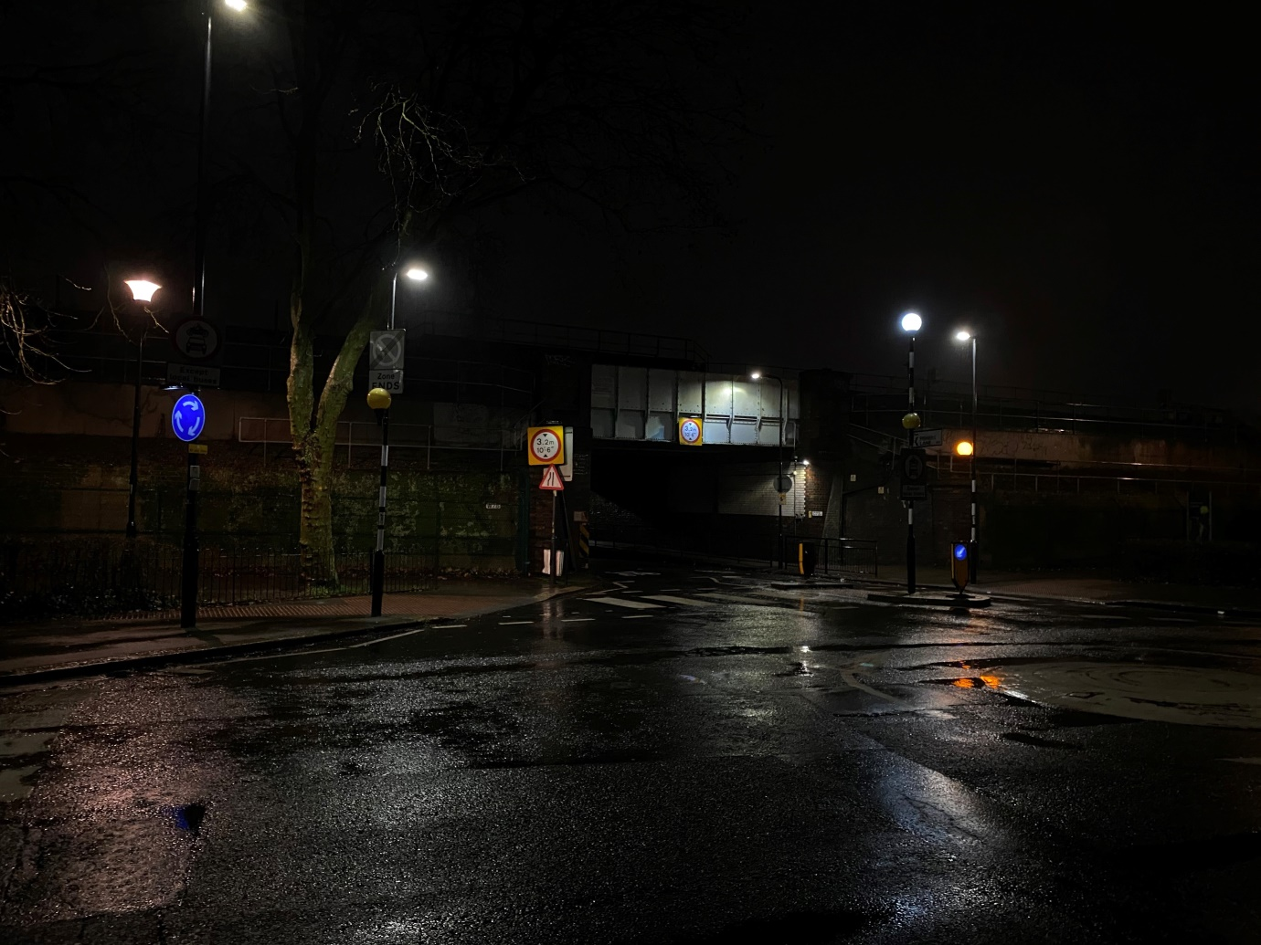

Ealing Council will no doubt claim that there is no legal requirement to illuminate the signs, being in a 20 mph zone. However, the fact that Ealing has chosen to illuminate every other sign, but not the (often adjacent) enforcement signs, makes the signs impossible to see.
For these reasons I believe that the signage is evidently unclear and inadequate to convey the restriction. As such, there was no contravention of the Local Authorities and Transport for London Act 2003 and the PCN should be cancelled. I invite the Council to do so at the earliest opportunity.

