Representation for turning left into Fishers Lane from South Parade (daytime)
PCN number:
I make representations against the above numbered PCN on the ground that the contravention did not occur as the signage is unclear and inadequate to convey the restriction. As such “there was no failure to comply with an indication” under 1(4)(b)(ii) of Schedule 1 of London Local Authorities and Transport for London Act 2003.
I saw no signs at the time of the alleged contravention that inform of this moving traffic prohibition. Upon receipt of the PCN I made some investigations and I make the following observations in support of my contention.
The traffic order is enforced by two signs of type 619 “Motor vehicles prohibited”, as illustrated under item 12 of the sign table in Schedule 3, Part 2 of The Traffic Signs Regulations and General Directions 2016.
I made a daylight inspection of the signs and found the following: one of these signs is not at all visible to the approaching motorist, and the other is barely visible.
In the picture below, you will see 5 signs – there are in fact 6. Four of these signs are very visible to the approaching motorist:
- the height restriction sign
- the Zone Ends sign,
- the lane narrowing sign
- the roundabout sign
All of these signs are angled to face the oncoming motorist.
The first of the “Motor vehicles prohibited sign” is not visible to the motorist and is not even visible in the picture. I have labelled its location in the photograph, angled at 90 degrees away from the approaching driver.
The second “Motor vehicles prohibited” sign has also been deliberately pointed away from the motorist (by approximately 80 degrees), and is barely visible, being apparent only as a thin ellipsoid in shape, rather than circular. In fact, it has been deliberately pointed towards the enforcement camera, and away from the innocent motorist, so that PCN can be enforced with its image, rather than it serving its intended purpose of instructing the motorist of a prohibition. This is especially evident as the roundabout sign is located directly beneath it, but has been pointed towards the motorist for their benefit, and is visible as it should be. The prohibition sign is not.
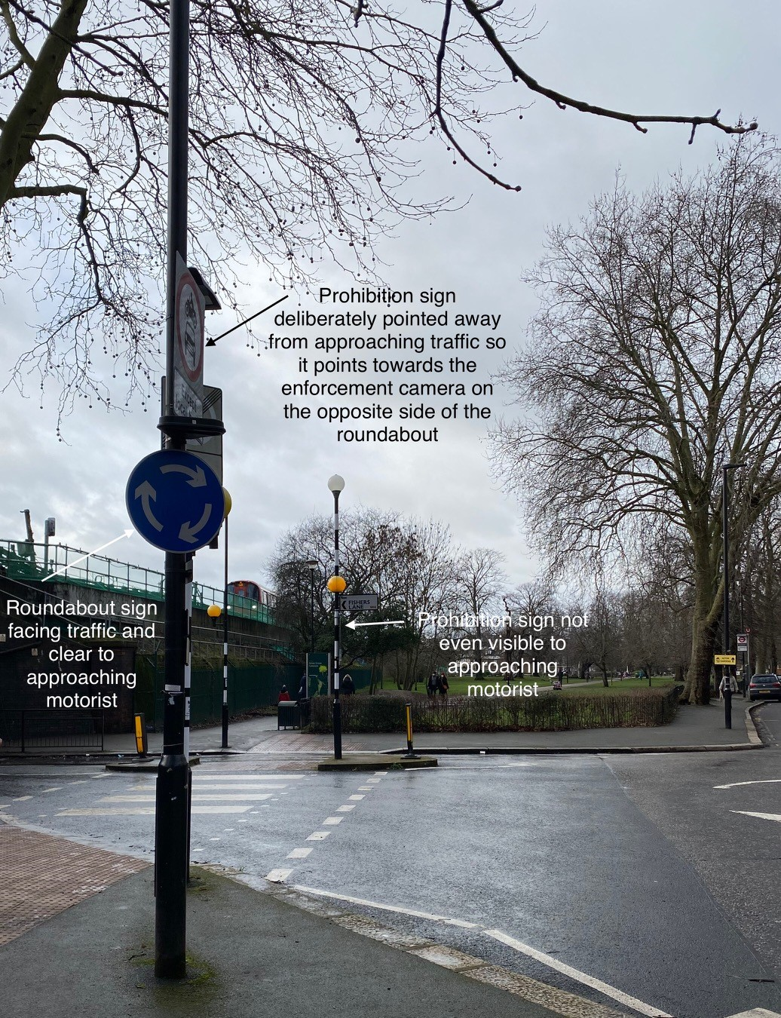
In support of my appeal, I point to the recent decision by the Adjudicator in PCN ZY02096403 (17 December 2020) to allow an appeal on the grounds of inadequate signage because “yet another example of signage being rendered insufficiently visible and thus inadequate because it appears elliptical, and not circular, from the perspective of a motorist approaching it from the side. The prescribed description of this regulatory sign is a circular shape, not an ellipse.” The Adjudicator continued that the motorist “would have inadequate notice of the restriction until such time as it was impossible to avoid contravening it. I am unable to find that the signage is adequate”

For these reasons I believe that the signage is evidently unclear and inadequate to convey the restriction. As such, there was no contravention of the Local Authorities and Transport for London Act 2003 and the PCN should be cancelled. I invite the Council to do so at the earliest opportunity.

